Create an Account in Sendgrid

|  |  |
| --- | --- |
| Team ID | PNT2022TMID43073 |
| Project Name | Customer care registry. |

# Step 1:

Go to official Sendgrid website: [***https://sendgrid.com/***](https://sendgrid.com/), then click start for free.



# Step 2:

Then go to Registration Page, you need to give all the details required for creating a Sendgrid account and finally click create button. The below screenshot will show theregistration Process.

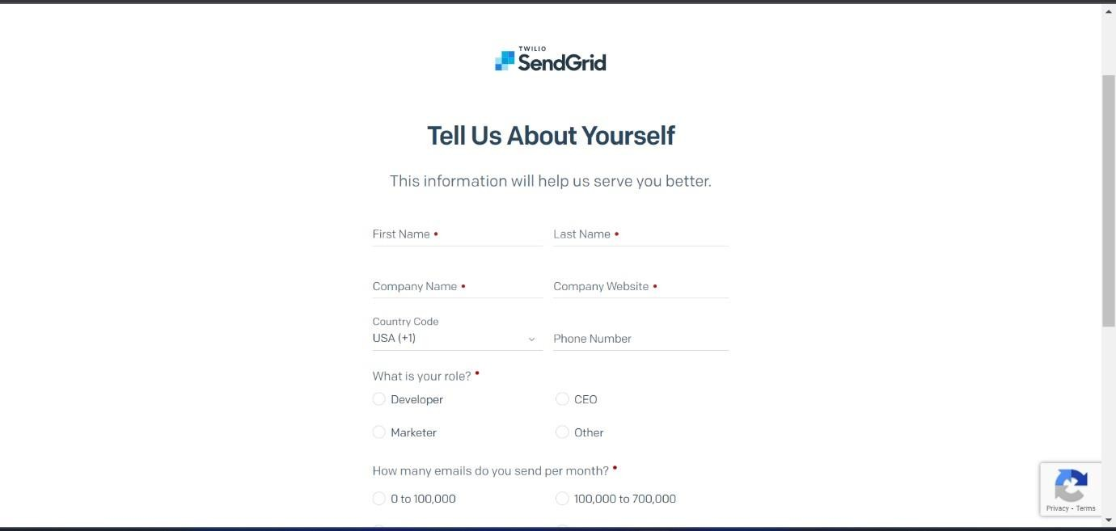

# Step 3:

Then it will redirect you to a home page of your sendgrid account.

# Step 4:

Finally, you have created your account and now you can access the sendgrid account.